
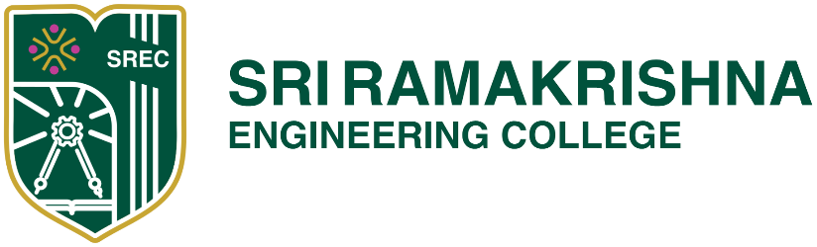
[Educational Service : SNR Sons Charitable Trust]

Vattamalaipalayam, N.G.G.O. Colony Post, www.srec.ac.in

Coimbatore – 641022. +917530089996

STUDENT AFFAIRS
Academic Year 2026 – 2027
Clubs Faculty Coordinator
Sl. No. | Name of the Club | Faculty Coordinator | Contact Number | Mail Id
 | CySIGMA | Mr.G.Ramsundar | 9843054556 | ramsundar.gurumoorthy@srec.ac.in
 | English Literary Society | Mrs.M.Hamsalatha | 9585733808 | hamsalatha.m@srec.ac.in
 | Fine Arts Club | Mrs. R.K.Ragavapriya  Mr. K. Robin Johny | 9942616087  9677967216 | ragavapriya.krishnasamy@srec.ac.in  robinjohny.k@srec.ac.in
 | Foss Club | Mr.N.Manoj | 6381764628 | manoj.n@srec.ac.in
 | Code Catalyst Club | Dr.V.Saveetha | 9442901511 | saveetha.v@srec.ac.in
 | Phoraratz Club | Dr. M. Chitra | 9787285841 | chitra.muthukumaravel@srec.ac.in
 | Quiz Club | Dr.K.Savitha | 9943833840 | savitha.krishnamurthy@srec.ac.in
 | Reading Movement Club | Dr P Suganya | 9942925566 | suganya.palanisamy@srec.ac.in
 | Tamil Mandram Club | Dr. S. Sakthivel | 9942715534 | sakthivel.s@srec.ac.in
 | Uyir Club | Dr.N.Gopalakrishnan | 9080516590 | gopalakrishnan.n@srec.ac.in
 | Yi YUVA Club | Dr.Thomas Renald | 9894956536 | thomasrenald.joseph@srec.ac.in
 | NCC | Dr.M.Ramesh | 9791871560 | ramesh.mari@srec.ac.in
 | Renewable Energy Club | Dr. Balachander K | 9894052923 | balachander.kalappan@srec.ac.in
 | SDG Club | Dr. G. Gopu | 9894422311 | gopu.govindasamy@srec.ac.in
 |  | Dr.B.Mathivanan | 9843266820 | mathivanan.bala@srec.ac.in

